
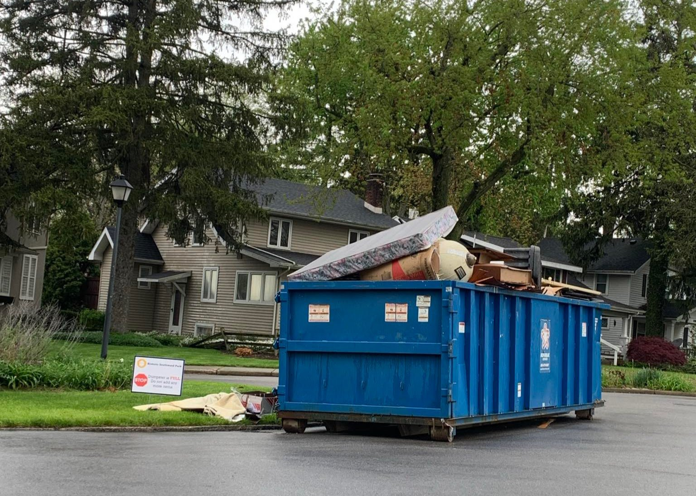
Acceptable Items
- Furniture
- Scrap Metal
- Construction Debris
- Electronics
- Appliances (NO Freon)

Community clean up day
-------------------------------------

Dumpster Day
April 11,2026
9Am-12PM
-------------------------------------Drop off Location:
DPW Garage
134 Westside Dr.
Vermontville, MI 49096

Eaton County’s Recycling trailer will be onsite for Recyclables also!
Sponsored By:
NO TIRES WILL BE ACCEPTED AT THIS TIME!

All Items must be dropped off at the drop of location. Brush and yard waste can be dropped off at the Village of Vermontville yard waste site on E Forest Street. Please do not put items by the curb they will NOT be picked up. Dumpster day is for Village of Vermontville Residents only- Address will be verified before unloading. Donations will be accepted to offset disposal fees.
For more information contact the Department of Public Works @ 517-726-1444

